CS610: Final exam
The programming part
Due: 12/21/2017, 11:58 P.M.

No delay is accepted whatsoever. After the due date I grade the test for 0
Post your answer in the folder Final Exam on the blackboard.
You can post your answers one time only.
I cannot answer the questions to help you, but if you like to clarify anything about the questions email me at mbadii@pace.edu. In this case let me know which part of a question is not clear for you.
Each question is for 20 points. Write your answers in this file below the word: “Answer” and post this file only.

Question 1: Complete the program under the word: Answer to be a parallel program using pthread to accomplish the same as the following serial program. For the following serial program, the user enters a line of text and the program outputs the number of occurrences of each character.
For the parallel program if we have n threads we should divide the line into n segments (and not into n characters) and let each thread counts the characters of its segment.

//File name: a.c
#include <stdio.h>
#include <stdlib.h>
#include <string.h>

#define ASCIIs 127 //ASCII characters from 0 to 127
#define atmost 1000

char letters[atmost + 1]; //Extra location for the string terminator '\0'
int count[ASCIIs];

int main(){
int i, index;

for(i = 0; i < ASCIIs; i++)
count[i] = 0;

printf("Enter a line not larger than 100 characters.\n");
fgets(letters, atmost+1, stdin);//Read a line into array letters. This function adds '\0' to the end of the string

for(i = 0; i < strlen(letters); i++){
index = (int)letters[i];
(count[index])++;
}

for(i = 33; i < ASCIIs; i++)
if(count[i] != 0)
printf("Number of %c is: %d\n", i, count[i]);
return 0;
}

For example:

Enter a line not larger than 100 characters.
for(i = 0; i < strlen(letters); i++){
Number of ( is: 2
Number of ) is: 2
Number of + is: 2
Number of 0 is: 1
Number of ; is: 2
Number of < is: 1
Number of = is: 1
Number of e is: 3
Number of f is: 1
Number of i is: 3
Number of l is: 2
Number of n is: 1
Number of o is: 1
Number of r is: 3
Number of s is: 2
Number of t is: 3
Number of { is: 1

The boldfaced line is what the user entered.

Answer:

//File name: a.c
#include <stdio.h>
#include <stdlib.h>
#include <string.h>
#include <pthread.h>

#define thread_count 2
#define ASCIIs 127 //ASCII characters from 0 to 127
#define atmost 1000
typedef struct{
int rank, start, end;
} record_type;

char letters[atmost+1]; //extra location for '\0'.
int count[ASCIIs], h; //h holds the length of the segment
pthread_mutex_t mutex[ASCIIs];
int string_length = 0;

void *task(void* rank);

int main(){
pthread_t* thread_handles;
int i;
long thread;
record_type data[4];

for(i=0; i<ASCIIs; i++){
count[i] = 0;
}

printf("Enter a line not larger than 100 characters:\n");
fgets(letters, atmost+1, stdin);

string_length = strlen(letters);

while (string_length % thread_count != 0) {
strcat(letters," ");
string_length = strlen(letters);
}
h = string_length/thread_count;

for (i = 0; i < ASCIIs; ++i) {
pthread_mutex_init(&mutex[i], NULL);
}

thread_handles = malloc(thread_count*sizeof(pthread_t));

for(thread = 0; thread < thread_count; thread++){
pthread_mutex_init(&mutex[thread], NULL);
data[thread].rank = thread;
data[thread].start = thread * h;
data[thread].end = h * (thread + 1);
pthread_create(&thread_handles[thread], NULL, task, &data[thread]);
}

for(thread = 0; thread < thread_count; thread++){
pthread_join(thread_handles[thread], NULL);
}

for (i = 0; i < ASCIIs; ++i) {
pthread_mutex_destroy(&mutex[i]);
}

free(thread_handles);

for(i = 33; i < ASCIIs; i++){
if(count[i] != 0)
printf("Number of %c is: %d\n", i, count[i]);
}
return 0;
}

void *task(void* rank){

int i,index=0;
record_type *data = (record_type *)rank;
int j = data->start;
int end = data->end;

for(i = j; i < end; i++){
index = (int)letters[i];
pthread_mutex_lock(&mutex[i]);
(count[index])++;
pthread_mutex_unlock(&mutex[i]);
}

return NULL;
}

Question 2: Program the programming assignment 5.2 on pages 267-268 (and not exercise on page 263) of your textbook. Copy/paste your parallel program under the word: Answer in this file. I copy/pasted the description of the question in the next page.
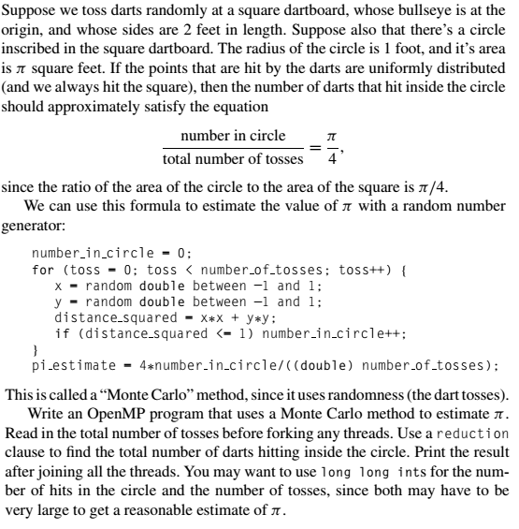

Answer:

#include <stdio.h>
#include <stdlib.h>
#include <omp.h>
#include <time.h>

long long int total_number_of_tosses, tosses_per_thread;//Total number of tosses
long long int number_in_circle = 0; //Each thread is adding its result to this variable.
int thread_count; //Number of threads.

//returns a random number in the range -1 to 1.
double rand_double() {
return 2 * (rand() / (double)RAND_MAX) - 1;
}

int main()
{
double pi_estimate;//At the end the function main stores the output into this variable and print it.

printf("Enter number of threads and the total number of tosses: ");
scanf("%d%lld", &thread_count, &total_number_of_tosses);
srand((long)time(NULL));

//Using the following loop to make it divisible by thread_count.
while (total_number_of_tosses % thread_count != 0) {
total_number_of_tosses++;
}
//Complete the rest of this function.
tosses_per_thread = total_number_of_tosses/thread_count;

#pragma omp parallel num_threads(thread_count)
{
double x, y, distance_squared;
int toss,number_in_circle_in_thread=0;
for (toss = 0; toss < tosses_per_thread; toss++){
x = rand_double();
y = rand_double();
distance_squared = x*x + y*y;
if (distance_squared <= 1)
number_in_circle_in_thread++;
}

#pragma omp critical
number_in_circle += number_in_circle_in_thread;

}

pi_estimate = 4 * number_in_circle / ((double)total_number_of_tosses);
printf("Estimated pi = %f\n", pi_estimate);

return 0;
}

